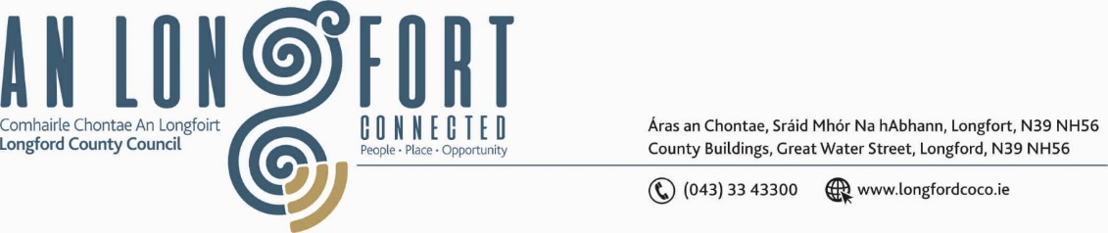

**GRANARD MUNICIPAL DISTRICT**

***Please note meeting will be held in Granard Library and via Microsoft Teams.***

**20 September 2022.**

**To: Each Member of Granard Municipal District.**

**Dear Member,**

You are requested to attend a Meeting of Granard Municipal District to be held in Granard Library and **via Microsoft Teams** on **Tuesday** **27 September 2022 at 3.30pm** to transact business, as set out on the Agenda hereunder.

**Yours sincerely**,

Ann Marie Mc Keon

______________________

**Ann Marie Mc Keon,**

**Meetings Administrator.**

**AGENDA**

Prayer before meeting.

**1.** Confirmation of Minutes as follows: -

* Granard Municipal District Meeting held on 25 July 2022 – copy enclosed.
* Granard Municipal District Committee Meeting held on 25 July 2022 – copy enclosed.

**2.** Matters arising from Minutes.

**3.** Declaration of Interest by Members.

**4.** Management Report incorporating Area Engineer’s Progress Report – enclosed.

**5.** Proposed Projects/Expression of Interests.

**6.** Community Grant Support Scheme 2022 – enclosed.

**7.** Special Projects/Discretionary Funds 2022 – enclosed.

**8. Notices of Motions, submitted by Councillors, as listed hereunder –**

**Councillor PJ Reilly**

I wish to put a motion to the meeting for Granard Municipal District to host a Civic Recognition for our Local All Ireland Winner in the recent Fleadh Cheoil Ms Aoibhinn Ni Loinsigh CCE John Duggan. Aoibhinn won her All Ireland title for playing the Button Accordion.

**Councillor Colin Dalton**

I call on Longford County Council to carry out a low-cost safety scheme at Mallon’s Cross, Derrynacross, Ballinalee.

**Councillor Turlough McGovern**

I call on Longford County Council to put in place a pedestrian crossing outside Sacred Heart Primary School on Lower Barrack Street, Granard.

**Councillors Turlough Mc Govern & PJ Reilly**

I call on Longford County Council to commence the process of taking in charge Barrack Lane Road from the Eircom Building to the T-junction at the top of said road.